**Project Report : [CV User Interaction]**

With the change of the era, the concept of human thinking is changing.  As a result, the implementation of the bizarre necessary ideas of people is being implemented by using technology. Like: Artificial Intelligent, image processing etc. In which modern people of the modern age are advanced and progress towards progress.  In this project, we use image processing technology. Image processing is a method to perform some operations on an image, in order to get an enhanced image or to extract some useful information from it.

**In this project is simple, we are building a smart “music player” which is control by user interaction...**

**Features of our Application:**

* User can listen to music.
* Can Play or Pause.
* Can Control Next, Previous and Stop by using Button.
* Also Control Smart Color Button Smoothly.

**Use Component:**

* Computer.
* NetBeans.
* **GUI Design.**
* **JAVA OpenCV.**
* **JavaCV Libraries.**
* **JavaMediaFamework** (jmf-2_1_1e-windows-i586.exe)
* **Color Board** (Red,Green,Blue)
* Webcam.
* WebCamera Stand.

**Project Demo & Use Procedure:**

User use this Application (Smart Music Player) Regular ‘Media Player’ Using system or Smart color button controlling by using web camera.

**1st Look:**

When user click this application, then user see this main windows.

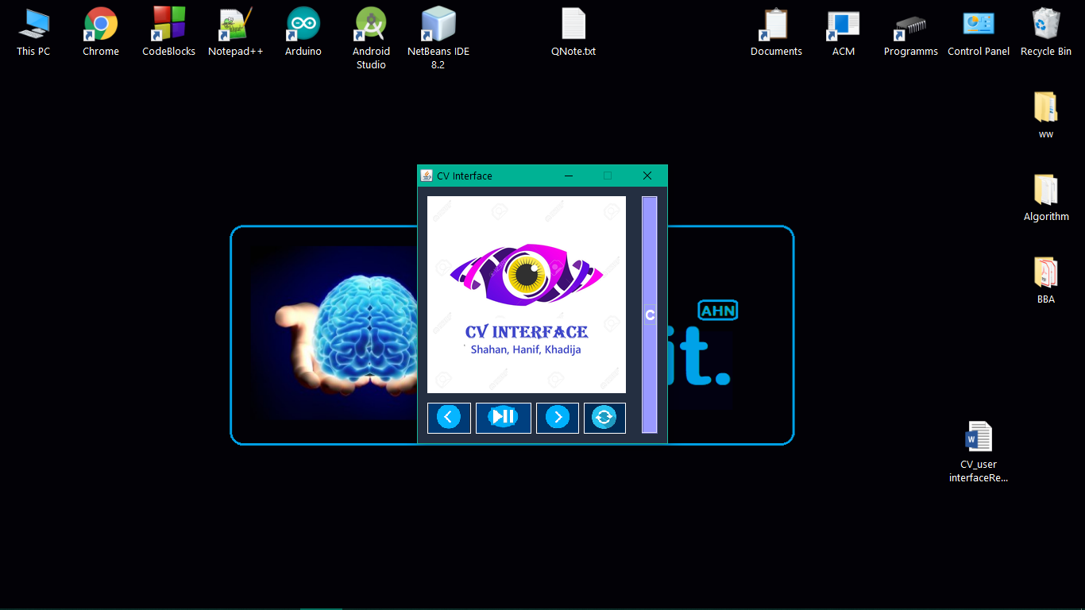

User can use this four button controlling music player (Previous, Play or Pause, next and stop) which position under the music player main windows.

**2nd Look:**



When user click this Smart Button. Then user see Four CanvasFrame.

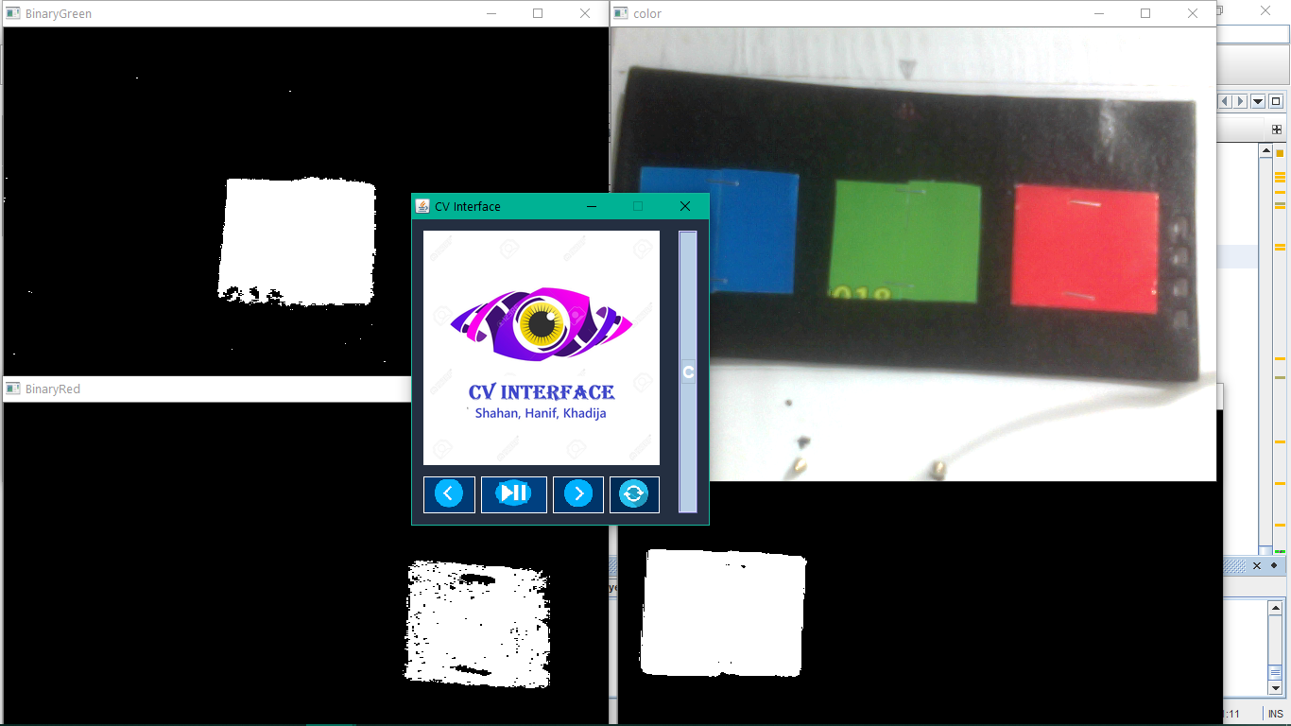

Which is show:

1. Color Image.

2. Red Button Detect.

3. Green Button Detect.

4. Blue Button Detect.

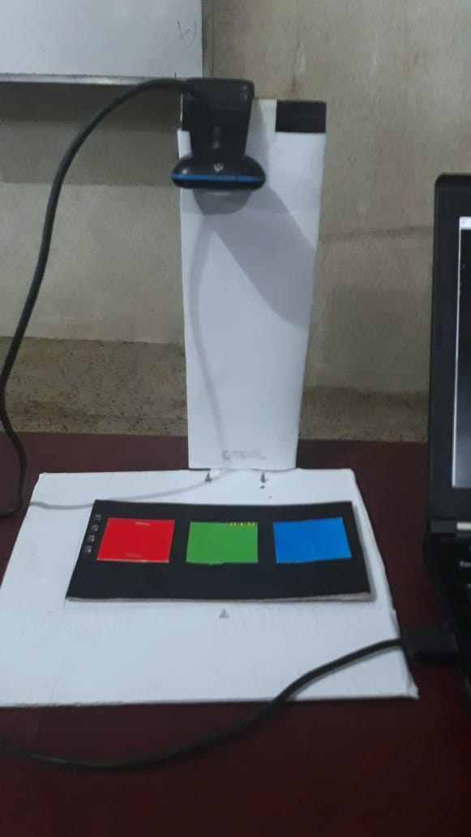

Fig: Camera, **Color Board** (Red, Green, Blue), WebCamera Stand.

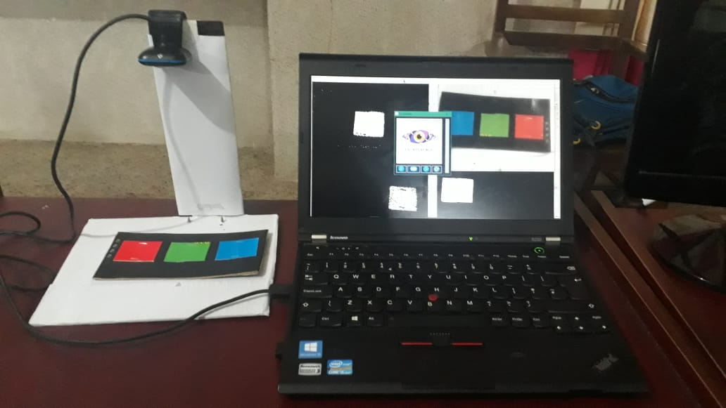

Fig: Full Project.

When user ‘The Color Board’ set to Web Camera range then use can control music player smartly by using this three smart color button.

**Building Language:**

We have created this application using the Java programming language.

We hope this Application (CV_Usre Interaction) will be useful to many people.